Predicting Cavitation Index in Radial Gated Bottom Outlets

A DISSERTATION
Submitted in partial fulfilment of the requirement
For the award of the degree of

Bachelor of Technology
in
CIVIL ENGINEERING
by

SUJAL
ROLL NO. 12211082
Under the supervision of
Dr. N. K. Tiwari


DEPARTMENT OF CIVIL ENGINEERING
NATIONAL INSTITUTE OF TECHNOLOGY, KURUKSHETRA – 136119, HARYANA (INDIA)
November, 2025

CANDIDATE DECLARATION
I hereby declare that the work being presented in this dissertation entitled “Predicting Cavitation Index in Radial Gated Bottom Outlets”, submitted towards the partial fulfilment of the requirements for the award of degree of Bachelor of Technology in Civil Engineering, National Institute of Technology, Kurukshetra, is an authentic record of my work carried out from June 2025 to July 2025, under the guidance of Dr. N. K. Tiwari, Department of Civil Engineering, National Institute of Technology, Kurukshetra.

I have not submitted the matter embodied in the dissertation for the award of any other degree

Dated:
Place: Kurukshetra SUJAL
(12211082)

CERTIFICATION
This is to certify that the above statement made by the candidate is true to the best of my knowledge and belief.

Dr. N. K. Tiwari
Professor
Department of Civil Engineering
NIT Kurukshetra
Contents
LIST OF FIGURES 5
LIST OF TABLES 6
CHAPTER 1 7
INTRODUCTION 7
1.1 General 7
1.2 The Cavitation Index 8
1.3 Present State of Knowledge 9
1.4 Problems to be Investigated 10
1.5 Layout of Report 10
CHAPTER 2 12
LITERATURE REVIEW 12
2.1 General 12
2.2 Prediction of Cavitation Index 12
2.3 Synopsis of Reviewed Literature 21
2.4 Scope of the study 22
CHAPTER 3 24
THEORETICAL BACKGROUND AND METHODOLOGY 24
3.1 Materials and Methods 24
3.2 Experimental Apparatus 24
3.3 Experimental Procedure 25
3.4 Performance Metrics for Model Evaluation 25
3.5 Dimensional & Non-Dimensional Datasets 26
3.6 Proposed Artificial Intelligence Models 30
3.6.1 Regression Models 30
3.6.2 Ensemble Learning Models 31
CHAPTER 4 36
RESULT AND DISCUSSION 36
4.1 Analysis of Variables and Correlation Diagrams 36
4.2 Comparison of Results for Dimensional Data 40
4.3 Comparison of Results for Non-Dimensional Data 45
4.4 Sensitivity Analysis 50
4.4.1-Dimensional Dataset 51
4.6.2 Non-Dimensional Dataset 52
4.5 SHAP Analysis 53
4.5.1-Dimensional Dataset 54
4.5.2 Non-Dimensional Dataset 55
CHAPTER 5 57
CONCLUSION AND FUTURE WORK 57
REFERENCES 60

LIST OF FIGURES
Figure 3.1 A schematic representation of the experimental apparatus, including the pump, reservoir, flowmeter, gate, and air vent 24
Figure 4.1 Correlation plots for the (a) dimensional and (b) non-dimensional datasets. 38
Figure 4.2 Relative error plot for all models on the dimensional dataset 42
Figure 4.3 Taylor diagrams comparing model performance for (a) Training and (b) Testing phases 43
Figure 4.4 Scatter plots of predicted vs. actual cavitation index for (a) Training and (b) Testing phases for dimensional dataset 44
Figure 4.5 Relative error plot for all models on the non-dimensional dataset 47
Figure 4.6 Scatter plots of predicted vs. actual cavitation index for (a) Training and (b) Testing phases for non-dimensional dataset 48
Figure 4.7 Taylor diagrams comparing model performance for the non-dimensional (a) Training and (b) Testing phases. 49
Figure 4.8 Sensitivity analysis results for the dimensional dataset, showing (a) GBM Feature Importances, (b) Morris Analysis, and (c) Sobol Indices. 50
Figure 4.8 Sensitivity analysis results for the non-dimensional dataset, showing (a) GBM Feature Importances, (b) Morris Analysis, and (c) Sobol Indices. 53
Figure 4.9 SHAP summary plots for the dimensional dataset on the testing data, showing (a) the beeswarm plot of SHAP values for each feature and (b) the bar chart of mean absolute SHAP values. 55
Figure 4.10 SHAP summary plots for the non-dimensional dataset on the testing data, showing (a) the beeswarm plot of SHAP values for each feature and (b) the bar chart of mean absolute SHAP values. 55

LIST OF TABLES
Table 3.2 Summary Statistics of dimensional dataset 28
Table 3.3 Summary statistics for non-dimensional dataset 29
Table 4.1 Performance of different models on dimensional dataset 39
Table 4.2 Performance of different models on non-dimensional dataset 45
Table 4.3 Sensitivity analysis using the OFAT on GBM model for dimensional dataset 51
Table 4.4 Sensitivity analysis using the OFAT on GBM model for non-dimensional dataset 52

CHAPTER 1

INTRODUCTION

1.1 General
Dams are cornerstones of modern water resource management, providing vital services like flood control, irrigation, and hydropower. Central to their function is the spillway, a structure engineered to safely release excess water and protect the dam from the catastrophic threat of overtopping. However, the very nature of these structures—designed to handle massive volumes of water at high speeds—creates a significant engineering challenge: a destructive phenomenon known as cavitation. Cavitation is the formation and subsequent collapse of vapor-filled cavities or bubbles in a flowing liquid because of local pressure reductions. If the pressure in a flowing liquid drops below its vapor pressure, the liquid vaporizes in the form of small bubbles. When these bubbles enter a region of higher pressure, they collapse and the resulting pressures may be large enough to cause pitting and erosion of the solid boundary—a process called cavitation damage. Cavitation can occur in any liquid flow where local pressure is reduced to vapor pressure. In spillways and chutes, cavitation is generally caused by flow separation resulting from surface irregularities, misalignment, or abrupt curvatures (Falvey, 1990). This damage can compromise the spillway's structural integrity, leading to costly repairs and, in the worst cases, threatening the safety of the entire dam. Given the substantial financial and safety implications, accurately predicting and mitigating cavitation has become a primary focus for hydraulic engineers. For decades, the go-to methods for managing cavitation risk involved a combination of physical model testing and the use of empirical formulas. While these traditional approaches have been effective, they are often time-consuming and can struggle to capture the complex interplay of factors that initiate cavitation. The last few years have seen a surge in computational methods offering new tools for analysis. Numerical simulations using Computational Fluid Dynamics (CFD) now allow for detailed investigations of flow dynamics (Nikrou & Pirboudaghi, 2024; Abbas et al., 2024). At the same time, the rise of artificial intelligence and machine learning (ML) presents a powerful new way to approach prediction and risk assessment. Researchers have started to apply various ML techniques, like Support Vector Machines (SVM) and K-Nearest Neighbors (K-NN), to predict cavitation damage levels with encouraging results (Bagherzadeh et al., 2025; Fadaei-Kermani et al., 2018). These data-driven strategies hold the potential to deliver more accurate and efficient predictions, paving the way for safer and more economical hydraulic structure designs.

1.2 The Cavitation Index
The primary tool for quantifying the risk of cavitation is the cavitation index (σ), a dimensionless parameter that captures the relationship between the local flow pressure and the forces of inertia. It provides a standardized way to measure a flow's susceptibility to cavitation and is defined as:
$$σ=\frac{P-P_{v}}{0.5ρV^{2}}$$
where P is the absolute local pressure, $P_{v}$ is the vapor pressure of the water, ρ is the density of the water, and V is the characteristic flow velocity.
The principle behind the index is straightforward: cavitation is likely to begin when the flow's cavitation index (σ) falls below a critical threshold ($σ_{i}$​) that is specific to the structure's geometry. A higher cavitation index means a larger margin of safety. Groundbreaking work by Falvey (1990) established that a critical value of approximately 0.20 serves as a key benchmark for many hydraulic structures; flows with a cavitation index below this are at significant risk of damage. Therefore, accurately predicting this index along the entire length of a spillway is the most crucial step in assessing and mitigating cavitation. The value of σ itself is the result of a complex dance between various hydraulic and geometric parameters, including flow velocity, pressure head, gate openings, and conduit geometry (Baylar et al.).

1.3 Present State of Knowledge
Our understanding of cavitation and how to predict it has evolved considerably. The journey began with extensive experimental programs and the development of foundational empirical relationships. The work of Baylar et al., which produced a robust empirical formula for the cavitation index from a dataset of 504 experiments, stands as a prime example of this traditional approach. However, the sheer complexity of the phenomenon and its many influencing variables have made it difficult to create formulas that are universally applicable. To move past these limitations, researchers have increasingly embraced more sophisticated modelling techniques. Numerical methods, especially CFD, have become instrumental in simulating the intricate two-phase flow dynamics and pinpointing the low-pressure zones where cavitation is born (Nikrou & Pirboudaghi, 2024; Abbas et al., 2024). While these simulations offer deep insights, they demand significant computational power and must be carefully validated. Most recently, the field has witnessed a paradigm shift toward data-driven prediction using machine learning. This approach taps into the ability of algorithms to learn complex, non-linear patterns directly from data. Studies have successfully used various ML models, such as K-NN and SVM, mainly to classify different regions of a spillway into discrete risk categories (Fadaei-Kermani et al., 2015; Bagherzadeh et al., 2025). While these classification models are invaluable for risk assessment, they stop short of predicting the actual numerical value of the cavitation index. The use of advanced regression algorithms for this specific task is a promising, yet largely unexplored, frontier. Furthermore, although the accuracy of ML models is often highlighted, a thorough analysis of their predictive uncertainty and the sensitivity of their outputs to different input parameters is frequently missing.

1.4 Problems to be Investigated
This research is driven by the need for more advanced and dependable methods for predicting the cavitation index in hydraulic structures. The study aims to build upon the foundational experimental work of Baylar et al. by harnessing the power of modern machine learning regression techniques. The central questions this research seeks to answer are:
- Can we develop high-performance regression models? While past ML applications have largely focused on classification, a clear need exists for robust models that can directly predict the continuous value of the cavitation index. This research will delve into the effectiveness of several state-of-the-art regression algorithms for this purpose.
- How certain can we be about the predictions? A critical component of any engineering model is understanding its uncertainty. This study will employ statistical methods like bootstrapping and Monte Carlo simulations to quantify the confidence intervals of the model predictions, offering a completer and more realistic picture of potential risks.
- What are the key factors driving cavitation? Knowing which hydraulic parameters have the most significant impact on the cavitation index is vital for effective design. This research will use advanced sensitivity analysis techniques, including Morris, Sobol, and SHAP analyses, to identify these key drivers and to open the "black box" of the ML models to interpret their behaviour.

1.5 Layout of Report
The report is organized as follows:
- Chapter 1: Introduction: This chapter provides an overview of the problem of cavitation in hydraulic structures, introduces the cavitation index, summarizes the current state of knowledge, and outlines the specific objectives and scope of the study.
- Chapter 2: Literature Review: This chapter presents a detailed review of the relevant literature, covering the evolution of cavitation prediction methods from empirical formulas and physical modelling to numerical simulations and modern machine learning approaches.
- Chapter 3: Theoretical Background and Methodology: This chapter details the theoretical foundations of the machine learning algorithms, uncertainty analysis techniques, and sensitivity analysis methods employed in this research.
- Chapter 4: Results and Discussion: This chapter presents the performance results of the different machine learning models, the outcomes of the uncertainty and sensitivity analyses, and a detailed discussion of the findings and their implications.
- Chapter 5: Conclusions and Future Work: This chapter summarizes the key conclusions of the research and suggests potential avenues for future investigation.

CHAPTER 2

LITERATURE REVIEW

2.1 General
Before diving into the cavitation index prediction, a thorough review of the literature is required. A comprehensive literature review helps one understand the current state of knowledge, what are grey areas and what are the key problems which can be used to solve the problem at hand and address the knowledge gaps. Therefore, a detailed literature review is presented under the following headings.

2.2 Prediction of Cavitation Index
The prediction of the cavitation index is a critical aspect of designing safe and durable hydraulic structures. The methods for this prediction have evolved significantly over time, beginning with physical model testing and empirical formulas. With the growth of computing technology, numerical simulations became a dominant approach. Most recently, the application of artificial intelligence and machine learning has introduced powerful new tools for developing highly accurate predictive models. The essential studies conducted by researchers in each of these methodological areas will be discussed Falvey (1990) authored a foundational engineering monograph that established key design principles for mitigating cavitation damage in high-velocity chutes and spillways. The work defines the cavitation index (σ) and provides detailed data on how various surface irregularities, such as into-the-flow offsets, affect cavitation inception. It quantifies the factors influencing damage, noting that damage intensity is proportional to velocity raised to a high power (e.g., v⁵ or v⁶) and that air concentrations of around 7-8% can completely prevent damage in concrete. A major contribution was a quantitative framework for predicting damage using a Damage Potential ($D_{p}$) and a time-dependent Damage Index ($D_{i}$), where a $D_{i}​$ value greater than 10,000 indicates major damage is likely. The monograph provides specific design guidance, linking surface tolerances to the flow's cavitation index; for example, where σ is between 0.20 and 0.40, a "T3" tolerance allowing a maximum 6 mm offset is specified. (This foundational work established the understanding of cavitation phenomena in hydraulic structures, introducing critical criteria for cavitation damage prevention. Falvey's work defined the cavitation index (σ) as a dimensionless parameter and suggested a critical value of 0.20 as a threshold where the potential for damage becomes significant and mitigation measures like aeration should be considered). Chanson (1994) investigated the complex processes of both aeration and the often-overlooked phenomenon of de-aeration at bottom aerator devices on high-velocity spillways. The study highlights that while aerators are effective at entraining large volumes of air, a significant de-aeration process occurs in the impact region where the aerated jet returns to the spillway floor. A re-analysis of several model-scale experiments revealed that this de-aeration can be substantial, with up to 80% of the air entrained along the jet being lost as it strikes the channel bed. The author developed an empirical relationship showing that the amount of de-aeration is primarily a function of the jet's impact angle with the spillway bottom, quantified by the formula:
$$\frac{Q_{air}^{de-aeration}}{Q_{air}^{max}} = 0.0763.(θ_{impact }- α)$$
where angles are in degrees. This finding led to the critical design recommendation that aerators should be configured to minimize this impact angle—for example, by using flat ramps or offsets only—to maximize the air concentration retained for downstream cavitation protection, where field data indicates a concentration of 4% to 8% is required for velocities up to 44 m/s. Lee and Hoopes (1996) introduced a novel model to predict cavitation damage by applying fuzzy mathematics, designed to handle the imprecise nature of damage boundaries and the complex interaction of influencing factors. Their comprehensive model evaluates four primary factors: the cavitation index (σ), flow velocity (v), material strength (S), and operating time (t). The model defines five discrete Cavitation Damage Levels (CDLs) from "none" to "major" and uses membership functions to map the input factors to these levels. The membership function for velocity, for instance, reflects the finding that damage is proportional to $v^{6}$. The model was validated using operational data from the Glen Canyon Dam spillways with specific parameters, including an inception index of $σ_{i} = 1.0$ a major damage index of $σ_{ch} = 0.2$, and factor weights of $w_{σ} = 0.4$for the cavitation index and $w_{v} = 0.6$ for velocity. The model's predictions were closely aligned with field observations; for the left spillway, it predicted the onset of major damage between stations 7+33 and 7+63 by June 6, 1983, which corresponded well with the timing and location of the actual catastrophic failure. Dong and Su (2006) conducted an experimental and theoretical investigation into cavitation control through aeration, focusing on the compressible characteristics of high-velocity flows ranging from 20 m/s to 50 m/s. Their experiments, performed in a non-circulating water tunnel, demonstrated that aeration significantly increases the pressure within the cavitation region. For instance, at a velocity of 21.3 m/s, introducing an air concentration of 10.9% raised the time-averaged pressure from -23.45 kPa to +29.53 kPa. This effect was attributed to the formation of compression or shock waves, a consequence of the reduced speed of sound in the air-water mixture, which was calculated to be as low as 32.1 m/s for the given conditions, resulting in a Mach number of M=0.64. The most critical result of their study was the development of an empirical formula that quantifies the minimum air concentration ($C_{min}$) required to prevent cavitation erosion. Based on 2-hour duration tests on concrete specimens, they established that this relationship follows a semi-cubical parabola, expressed as $C_{min}=0.00018.V^{3/2}$. This formula provides a direct, data-driven tool for determining the necessary aeration level for protecting concrete surfaces at a specific flow velocity. Baylar and Batan (2010) applied artificial intelligence techniques to model the complex process of oxygen transfer in free-flowing gated closed conduits. Their objective was to predict the standardized oxygen transfer efficiency ($E_{20}$) using two distinct AI approaches: Adaptive Network-based Fuzzy Inference Systems (ANFIS) and Least Squares Support Vector Machines (LS-SVM). The models were developed using a dataset of 54 experimental measurements from a previous study. The Froude number (Fr) at the gate and the dimensionless gate opening to conduit length ratio (h/L) served as the two input variables. A comprehensive comparison of the models was conducted using a three-fold cross-validation method. The optimal ANFIS model, which utilized a triangular membership function, achieved an average coefficient of determination ($R^{2}$) of 0.9853 and an average root mean square error (RMSE) of 0.0090. However, the LS-SVM model using a Radial Basis Function (RBF) kernel demonstrated superior performance, yielding a higher average $R^{2}$ of 0.9927 and a lower average RMSE of 0.0073. The study concluded that the LS-SVM model provided an extremely accurate prediction, validating the use of these advanced computational methods for complex hydraulic engineering problems. Unsal et al. (2014) utilized Genetic Expression Programming (GEP), a soft computing technique based on genetic algorithms, to develop predictive models for oxygen transfer efficiency in gated conduits. The study's primary goal was to generate explicit mathematical formulas for predicting standardized oxygen transfer efficiency ($E_{20}$) in two distinct flow regimes: high-head and free-surface flow. The models were trained and tested on two separate experimental datasets, each containing 54 data points, with the Froude number (Fr) at the gate and the dimensionless gate opening to conduit length ratio (h/L) serving as the input variables. For each flow type, 36 data points were used for training and 18 for testing. Two distinct models were successfully developed. For the high-head gated conduit, the GEP model produced a complex trigonometric formula (Model I) that achieved a high correlation coefficient of $R^{2}=0.948$ and a low mean square error (MSE) of 0.0076 on the testing dataset. For the free-surface gated conduit, a different formula was generated (Model II), yielding an $R^{2}=0.941$ and an MSE = 0.0075. The study successfully demonstrated the capability of GEP to not only accurately model a complex hydraulic process but also to provide explicit mathematical equations for prediction, an advantage over other "black-box" soft computing methods. Fadaei-Kermani et al. (2015) presented a predictive method for assessing cavitation damage on spillways using the K-nearest neighbor (K-NN) machine learning model. The model classifies cavitation risk into five discrete damage levels, ranging from 'No damage' to 'Major damage,' based on a single input feature: the flow cavitation index (σ). The damage thresholds were defined by specific ranges of σ, with 'Major damage' corresponding to σ ≤ 0.17. The K-NN model was trained and tested using data from the Shahid Abbaspour dam spillway in Iran, for which cavitation indices were calculated along the chute for eight different flow rates ranging from 500 to 3,300 m³/s. A four-fold cross-validation process was used to determine the optimal number of neighbors, identifying K=15 as the most effective value to minimize error. The model predicted that the highest risk—'Major damage'—would occur in the regions 200 m to 250 m downstream from the spillway crest, a finding that was consistent with the locations of observed damage from past flood events. The model's predictive accuracy was quantified by a strong Pearson correlation coefficient of R = 0.862 and a root mean square error (RMSE) of 0.346, demonstrating the suitability of the K-NN approach for this application. Fadaei-Kermani et al. (2016) utilized a Computational Fluid Dynamics (CFD) approach to numerically detect the location and severity of potential cavitation damage on a dam spillway. Using the Flow-3D software coupled with the Renormalization Group (RNG) turbulence model, they simulated flow over the Doosti dam spillway for five different flow rates, ranging from 1,200 m³/s to 6,000 m³/s. The numerical model was validated by comparing its outputs for flow depth, velocity, and pressure against experimental data from a 1:50 scale physical model of the same spillway. The CFD model demonstrated strong accuracy, achieving a coefficient of determination of $r^{2}$ = 0.8354 and a normalized root mean square error of NRMSE = 0.0476 for flow pressure predictions. The simulated flow characteristics were then used to calculate the cavitation index (σ) along the spillway. Based on predefined damage thresholds (e.g., 'Major damage' for σ ≤ 0.17), the results indicated that the risk of damage increases with the flow rate, with "serious damage" predicted to occur at the ending parts of the chute, specifically in the region 300 m to 436 m from the spillway crest. Zounemat-Kermani et al. (2017) conducted a comprehensive comparison of machine learning models against traditional empirical formulas for estimating air demand in the bottom outlet conduits of dams. The study evaluated three machine learning methods—Genetic Expression Programming (GEP), Boosted Regression Trees (BRT), and Random Forest (RF)—using a robust dataset of 193 measurements collected from six different dams. Two distinct prediction scenarios were tested. In the first scenario, which aimed to estimate the absolute aerator air discharge ($Q_{a}$) using multiple hydraulic and geometric inputs, the BRT model was the most accurate, achieving an average Nash-Sutcliffe (NS) efficiency of 0.870 during testing. In the second scenario, which focused on predicting the dimensionless aeration coefficient (β) using only the Froude number as input, the GEP model demonstrated superior performance with an average NS of 0.447. This represented a significant improvement in accuracy over both the decision tree models and the best-performing empirical relationship (Campbell-Guyton). A key advantage of the GEP model highlighted by the authors was its ability to generate explicit non-linear equations for predicting both air demand and the aeration coefficient, providing a transparent and practical tool for design. Fadaei-Kermani et al. (2018) advanced their previous work by applying a Fuzzy K-Nearest Neighbor (Fuzzy-KNN) algorithm to predict the intensity and location of cavitation damage on a dam spillway. This approach enhances the standard K-NN model by incorporating fuzzy set theory, allowing the model to assign a degree of membership to each of the five predefined damage levels rather than a single 'crisp' classification, thereby better representing the gradual and uncertain nature of the damage process. The model was tested using a large dataset of 9,648 data points derived from a prior CFD simulation of the Karun-1 Dam spillway, with the cavitation index (σ) as the primary input attribute. Using 3-fold cross-validation, the optimal number of neighbors was determined to be K = 18. The Fuzzy-KNN model predicted that 'Major damage' (defined as σ ≤ 0.17) was most probable at the end of the chute, assigning a full membership degree of 1.0000 to this class in the region 210 m to 250 m from the crest, which aligned with historical damage reports. The model's accuracy was quantified with a Pearson's correlation coefficient of r = 0.873 and a normalized root mean square error of NRMSE = 0.110, with these results representing a measurable improvement in precision over their previous non-fuzzy K-NN model. Wahl and Falvey (2022) presented SpillwayPro, a comprehensive, energy-based software tool for the integrated analysis of water surface profiles, aerated flow, and cavitation potential on both smooth and stepped spillway chutes. The software utilizes a standard-step calculation method that incorporates rigorous mathematics to account for steep slopes and streamline curvature, bridging the gap between simplified empirical formulas and complex CFD models. Its primary advantage is the integration of specific modules for analysing cavitation risk and designing mitigation measures. For stepped chutes, a key focus of the work, the tool identifies the main cavitation risk as occurring in the non-aerated region upstream of the aeration inception point. To quantify this risk, SpillwayPro estimates the incipient cavitation index of the stepped surface using the relationship $σ_{c}=4f$, where f is the Darcy-Weisbach friction factor of the steps. The model also predicts the bottom air concentration ($C_{b}$), a critical parameter for cavitation protection in the aerated zone, using empirical relationships derived from extensive laboratory and prototype data. In a validation against the Aviemore Dam case study, SpillwayPro's predictions for mean air concentration (0.33 to 0.66) showed reasonable agreement with the measured field data (0.42 to 0.61), demonstrating its utility as a practical engineering tool for spillway design and analysis. Matos et al. (2022) conducted a detailed investigation into the extreme pressure fields on steeply sloping (53°) stepped spillways to assess the risk of cavitation. The study was based on hydraulic model investigations of three large-scale stepped chutes, where extensive pressure measurements were taken on the step faces. The results showed significant negative pressure fluctuations near the outer edge of the vertical step faces, particularly in the non-aerated region upstream of the inception point, with extreme minimum pressures (at 0.1% non-exceedance) reaching as low as -16 times the hydrostatic pressure head (γh). Two different approaches were used to predict the onset of cavitation. The first method, based on the extreme pressure data, yielded a critical cavitation index, $σ_{c}\left(C_{p0.1\%}\right)$ in the range of 0.75 to 0.80. The second method, based on the correlation between cavitation and the Darcy-Weisbach friction factor ($σ_{c}=4f$), produced a slightly lower critical cavitation index, $σ_{c\left(f\right)}$, between 0.55 and 0.60. Based on a comparative analysis of these methods, the study provides a critical design guideline: to avoid cavitation damage on this type of spillway without artificial aeration, the maximum unit discharge should be limited to 15−20 $m^{2}$/s for prototype step heights of 0.6 to 1.2 m. Discharges exceeding this threshold significantly increase the extent of the spillway reach prone to cavitation damage. Nikrou and Pirboudaghi (2024) employed a three-dimensional numerical model to analyse cavitation dynamics on the free ogee spillway of the Aghchai Dam. Using the Flow-3D software, the study simulated two distinct flow scenarios: a maximum design flood of 4,400 m³/s and a lower flow rate of 1,065 m³/s. The simulations utilized the Volume of Fluid (VOF) method to capture the free surface and the Renormalization Group (RNG) turbulence model to account for turbulence. For the 4,400 m³/s discharge, the model predicted a high likelihood of cavitation, with flow velocities reaching a maximum of 32.8 m/s and pressures dropping to a minimum of -7,466 Pa, well below the fluid's vapor pressure. Two critical locations for cavitation were identified: the apex of the ogee crest and the abrupt slope transition in the chute. In contrast, the simulation for the 1,065 m³/s discharge showed minimal cavitation risk; the maximum velocity was only 19.7 m/s, which was insufficient to cause the significant flow separation and pressure drops required for cavitation. The numerical findings were validated against the dam design consultant's results from the WS77 software, which also predicted a high damage potential at the maximum flow rate, confirming the reliability of the CFD approach for identifying specific locations of cavitation risk. Abbas et al. (2024) utilized a three-dimensional Computational Fluid Dynamics (CFD) model to investigate the relationship between flow rate, cavitation, and concrete abrasion on an ogee spillway. Using the ANSYS Fluent software, the study simulated five different flow rates, ranging from 100 m³/s to 717 m³/s, over a model of the Mandali Dam spillway in Iraq. The simulations employed the Volume of Fluid (VOF) method to track the air-water interface and the RNG k-epsilon (k-ε) turbulence model. The results demonstrated a direct correlation between flow rate and cavitation risk as the discharge increased, the cavitation index decreased. At the highest flow rate of 717 m³/s, the model calculated a minimum cavitation index of 0.234 at 9 meters from the crest, a value approaching the critical threshold where design modifications are typically required. The study further translated this cavitation risk into a prediction of concrete abrasion. It found that the spillway toe and chute were the most vulnerable areas, while the crest remained largely unaffected. The severity of the predicted abrasion increased with the flow rate, reaching a maximum abrasion thickness of 1.0 mm at the highest discharge of 717 m³/s. The abrasion prediction component of the model was validated against previous research, achieving a coefficient of determination of R² = 0.637. Bagherzadeh et al. (2025) presented a hybrid numerical and machine learning approach to predict cavitation damage on ogee spillways, combining a physics-based flow simulation with a data-driven predictive model. First, a three-dimensional, two-phase (air-water) flow over the Gelevard-Neka Dam spillway was simulated using FLOW-3D for six different discharges ranging from 500 to 2,500 m³/s. The CFD model, which used the RNG k-ε turbulence model, was validated against field data and achieved high accuracy, with a Normalized Root-Mean-Square Error (NRMSE) of 0.0196. The extensive dataset of hydraulic parameters (velocity, pressure, and cavitation index) generated by the CFD model was then used to train and test a Support Vector Machine (SVM). The SVM model was designed to classify cavitation risk into five discrete damage levels, from 'no damage' to 'major damage' (where major damage corresponds to σ ≤ 0.17). The SVM demonstrated strong predictive performance, achieving a correlation coefficient of R = 0.857 and a Root Mean Square Error (RMSE) of 0.133 on the testing data. The model predicted that the spillway is highly susceptible to cavitation damage, with the most severe risk ('major damage') located in the region 70 m to 190 m downstream from the spillway crest.

2.3 Synopsis of Reviewed Literature
Cavitation analysis has progressed significantly, from foundational empirical studies to advanced computational and machine learning models. Early research, exemplified by Falvey (1990) and Baylar et al., established the theoretical basis of the cavitation index and developed empirical formulas linking it to hydraulic parameters. Concurrently, studies by Chanson (1994) and Dong and Su (2006) focused on mitigation strategies through aeration. The advent of powerful computing led to numerical simulations, with researchers like Nikrou and Pirboudaghi (2024) and Abbas et al. (2024) utilizing Computational Fluid Dynamics (CFD) for high-fidelity, site-specific cavitation risk analysis. More recently, machine learning (ML) has emerged as an accurate and efficient alternative. Beginning with fuzzy logic applications by Lee and Hoopes (1996), the field now employs sophisticated algorithms. Studies by Fadaei-Kermani et al. (2015, 2018), Bagherzadeh et al. (2025), and Zounemat-Kermani et al. (2017) have demonstrated that models like K-Nearest Neighbor (KNN), Support Vector Machines (SVM), and Gene Expression Programming (GEP) can accurately predict cavitation damage, outperforming traditional empirical methods. While the literature shows successful progression in cavitation analysis, a gap remains in comprehensively evaluating modern regression models for direct prediction of the continuous cavitation index and in rigorously quantifying the uncertainty and sensitivity of these data-driven predictions. This study aims to expand upon the experimental work of Baylar et al. by developing a robust, data-driven framework for predicting the cavitation index in radial-gated bottom outlets using advanced machine learning techniques. The primary objective is to enable direct regression of the continuous cavitation index (σ), moving beyond categorical damage prediction to provide a more granular and preventative risk assessment tool.

2.4 Scope of the study
- Develop and compare a suite of advanced machine learning models—including Gradient Boosting Machine (GBM), CatBoost, XGBoost, Random Forest, and Extremely Randomized Trees (XRT)—for cavitation index prediction. Their performance will be benchmarked against Multiple Linear (MLR) and Non-Linear Regression (MNLR) models.
- Investigate the impact of dimensional versus non-dimensional datasets on model performance. Two datasets (one with raw dimensional parameters, the other with non-dimensional parameters like the Froude number) will be created to systematically evaluate their effect on predictive accuracy and model generalizability.
- Conduct a rigorous uncertainty analysis of the machine learning model predictions. The Bootstrap method and Monte Carlo simulations will be employed to generate confidence intervals for the predicted cavitation index, offering a probabilistic risk assessment.
- Perform a comprehensive sensitivity and feature importance analysis to enhance model interpretability. This will involve global sensitivity analyses using the Morris and Sobol methods to identify influential input parameters, complemented by SHAP (SHapley Additive exPlanations) analysis for detailed explanations of feature importance and interactions.

CHAPTER 3

THEORETICAL BACKGROUND AND METHODOLOGY

3.1 Materials and Methods
The methodology of this study is rooted in the experimental framework established by Baylar et al. The experiments were performed within the Hydraulic Laboratory at Firat University in Elazig, Turkey.

3.2 Experimental Apparatus
The experimental setup, as depicted in the schematic below, was designed to investigate the cavitation index in radial-gated bottom outlets. A pump was used to circulate water from a main reservoir into the pipe system. The water flow rate was precisely regulated using a flow control valve and measured with a calibrated electromagnetic flowmeter to ensure accuracy.

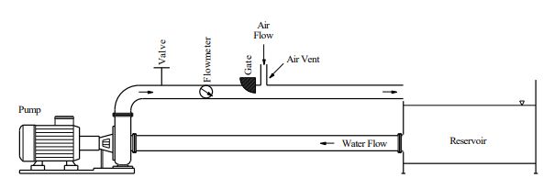
Figure 3.1 A schematic representation of the experimental apparatus, including the pump, reservoir, flowmeter, gate, and air vent
The core of the apparatus consisted of interchangeable bottom outlets to study the effect of cross-sectional geometry on the cavitation index. The three configurations were used a rectangular bottom outlet with a width of 60 mm and a height of 100 mm, a rectangular bottom outlet with a width of 100 mm and a height of 60 mm and circular bottom outlet with a 3-inch diameter. Notably, both rectangular outlets were designed to have the same cross-sectional area as the circular outlet. A radial gate was used to control the flow within the outlet. Positioned just downstream of this gate was a 20 cm high air vent, which allowed air to be entrained into the high-velocity water flow.

3.3 Experimental Procedure
Sr. No. | Bottom Outlet Cross-Section | Gate Opening Rate (φ) (%) | Bottom Outlet Length (L) (m) | Number of Experiments
1 | Rectangular (60 mm × 100 mm) | 10, 15, 20, 30, 40, 60 | 1, 2, 4, 6 | 168
2 | Rectangular (100 mm × 60 mm) | 10, 15, 20, 30, 40, 60 | 1, 2, 4, 6 | 168
3 | Circular (3-inch diameter) | 10, 15, 20, 30, 40, 60 | 1, 2, 4, 6 | 168
Table 3.1 Experimental Design for Bottom Outlet Cavitation Study

A comprehensive series of 504 experiments was conducted to analyse the cavitation index. The tests were systematically varied across different bottom outlet geometries, gate opening rates, and outlet lengths, as summarized in Table

Air velocity in the vent was measured using a Testo 435 anemometer, which has an accuracy of ±0.2 m/s + 1.5% of the measured value. To ensure reliable data, the anemometer was positioned vertically at the centre of the air vent, and measurements were recorded for a duration of at least 60 seconds for each experimental run. This extensive dataset formed the basis for the subsequent analysis of the cavitation index.

3.4 Performance Metrics for Model Evaluation
To assess the effectiveness of the regression models in predicting the cavitation index (σ), this study utilizes three key statistical performance metrics: the coefficient of correlation (CC), root mean square error (RMSE), and mean absolute error (MAE). These metrics provide a comprehensive evaluation of different aspects of model performance. The mathematical formulations used to calculate each metric are detailed below.
$CC=\frac{n\left(\sum_{i=1}^{n}{σ_{exp}σ_{pred}}\right) -\left(\sum_{i=1}^{n}{σ_{exp})(\sum_{i=1}^{n}{σ_{pred}}}\right) }{\sqrt{[n\left(\sum_{i=1}^{n}{σ_{exp}^{2}}\right)-{\left(\sum_{i=1}^{n}{σ_{exp}}\right)}^{2}]\left[n\left(\sum_{i=1}^{n}{σ_{pred}^{2}}\right)-{\left(\sum_{i=1}^{n}{σ_{pred}}\right)}^{2}\right]}}$
$RMSE=\sqrt{\frac{1}{n}\sum_{i=1}^{n}{{\left(σ_{exp }-σ_{pred}\right)}^{2}}}$
$MAE = \frac{1}{n}\sum_{i=1}^{n}{\left|σ_{exp }-σ_{pred}\right|}$
In these equations, $σ_{exp}$​ denotes the experimental (observed) values of the cavitation index obtained from the laboratory. Correspondingly, $σ_{pred}$ represents the predicted values of the cavitation index generated by the models. The symbol 'n' signifies the total number of data points included in the study.

3.5 Dimensional & Non-Dimensional Datasets
The cavitation index (σ) is a crucial dimensionless parameter that indicates the potential for cavitation to occur. Its prediction is based on eight critical input variables that define the geometry of the outlet and the characteristics of the air-water flow. The dimensional input parameters are L (Bottom Outlet Length) which represents the physical length of the bottom outlet conduit, measured in meters (m), φ (Gate Opening Rate) which is the ratio of the water's cross-sectional flow area to the total cross-sectional area of the bottom outlet, expressed as a percentage (%), $Q_{w}$​ (Water Flow Rate) which shows the volumetric flow rate of water through the bottom outlet, measured in cubic meters per second (m³/s), $Q_{a}$​ (Air Flow Rate) which represents the volumetric flow rate of air entrained through the air vent, measured in cubic meters per second (m³/s), h (Effective Water Depth) which is the ratio of the water flow's cross-sectional area to the width of the water surface under the gate, measured in meters (m), $V_{a}$​ (Air Velocity) which represents the mean velocity of the air flowing through the air vent, measured in meters per second (m/s), $R_{h}$​ (Hydraulic Radius) it is the ratio of the cross-sectional area of the flow to the wetted perimeter, measured in meters (m) and AR (Aspect Ratio) which indicates the ratio of the width to the height of the rectangular bottom outlet, which is a dimensionless quantity. The functional relationship for the dimensional analysis is expressed as:
$$σ=f(L,φ,Q_{w}​,Q_{a}​,h,V_{a}​,R_{h}​,AR)$$
But to create a more universal and scalable model, a non-dimensional analysis was also performed. This approach uses dimensionless numbers and ratios to describe the system's behaviour, making the results independent of the specific scale of the experiment. Since the output variable, the cavitation index (σ), is already dimensionless, it is modelled directly as a function of five key non-dimensional input parameters. The non-dimensional input parameters are Fr (Froude Number) which represents the ratio of inertial forces to gravitational forces in the flow. It is a dimensionless parameter, φ as defined previously, $R_{h}$​/L (Geometric Ratio) which is the ratio of the hydraulic radius to the bottom outlet length. This is a dimensionless parameter representing the geometric proportions of the conduit, $Q_{a}​/Q_{w}$​ (Air-Demand Ratio, β) it is the volumetric ratio of entrained air flow to water flow. This is a critical dimensionless parameter in two-phase flow analysis and AR. The functional relationship for the non-dimensional analysis is:
$$σ=f\left(F_{r},φ,R_{h}/L​​,Q_{a}/​Q_{w}​​,AR\right)$$
The Froude number ($F_{r}$) is a primary parameter in the non-dimensional analysis and is calculated based on the conditions at the vena contracta, using the effective depth under the gate. The equation is:
$$F_{r}=\frac{V_{w}}{\sqrt{g.h}}$$
where $V_{w}$​ is the mean water velocity under the gate in m/s, g is the gravitational acceleration in m/s², and h is the effective water depth in
Parameters | AR | L (m) | φ (%) | $$Q_{w}\left(m^{3}/s\right)$$ | $$Q_{a}\left(m^{3}/s\right)$$ | h (m) | $V_{a}$ (m/s) | R (m) | σ
Training
Mean | 1.095 | 3.221 | 28.859 | 11.932 | 13.574 | 3.797 | 8.545 | 0.008 | 7.956
St deviation | 0.444 | 1.920 | 16.808 | 7.542 | 12.991 | 2.656 | 8.159 | 0.003 | 16.923
Variance | 0.197 | 3.685 | 282.525 | 56.883 | 168.762 | 7.055 | 66.568 | 0.000 | 286.373
Kurtosis | -1.533 | -1.411 | -0.719 | -0.048 | 0.200 | -1.466 | 0.206 | -0.719 | 9.138
Skewness | 0.267 | 0.305 | 0.699 | 0.813 | 1.018 | 0.343 | 1.021 | 0.289 | 2.916
Range | 1.067 | 5.000 | 50.000 | 31.700 | 57.526 | 7.449 | 36.170 | 0.011 | 91.509
Minimum | 0.600 | 1.000 | 10.000 | 1.600 | 0.000 | 0.540 | 0.000 | 0.003 | -4.677
Maximum | 1.667 | 6.000 | 60.000 | 33.300 | 57.526 | 7.989 | 36.170 | 0.014 | 86.832
Sum | 441.400 | 1298.000 | 11630.000 | 4808.450 | 5470.424 | 1530.175 | 3443.530 | 3.102 | 3206.430
Count | 403.000 | 403.000 | 403.000 | 403.000 | 403.000 | 403.000 | 403.000 | 403.000 | 403.000
Testing
Mean | 1.063 | 3.366 | 30.396 | 13.137 | 13.683 | 3.986 | 8.606 | 0.008 | 8.902
Standard deviation | 0.429 | 1.938 | 17.545 | 8.579 | 13.483 | 2.787 | 8.475 | 0.003 | 18.629
Variance | 0.184 | 3.754 | 307.842 | 73.598 | 181.778 | 7.767 | 71.821 | 0.000 | 347.024
Kurtosis | -1.341 | -1.470 | -0.969 | -0.638 | 0.708 | -1.540 | 0.710 | -0.954 | 7.049
Skewness | 0.408 | 0.170 | 0.620 | 0.565 | 1.086 | 0.351 | 1.087 | 0.087 | 2.623
Range | 1.067 | 5.000 | 50.000 | 31.700 | 58.925 | 7.449 | 37.050 | 0.011 | 90.443
Minimum | 0.600 | 1.000 | 10.000 | 1.600 | 0.000 | 0.540 | 0.000 | 0.003 | -3.611
Maximum | 1.667 | 6.000 | 60.000 | 33.300 | 58.925 | 7.989 | 37.050 | 0.014 | 86.832
Sum | 107.400 | 340.000 | 3070.000 | 1326.800 | 1381.972 | 402.573 | 869.190 | 0.808 | 899.141
Count | 101.000 | 101.000 | 101.000 | 101.000 | 101.000 | 101.000 | 101.000 | 101.000 | 101.000
Table 3.2 Summary Statistics of dimensional dataset

m. By employing both dimensional and non-dimensional datasets, this study provides a holistic understanding of the system. The dimensional parameters are essential for direct, real-world applications, while the non-dimensional parameters generalize the findings, allowing the
Parameters | AR | φ | R/L | $$F_{r}$$ | $$Q_{a}/Q_{w}$$ | σ
Training
Mean | 1.095 | 28.859 | 0.004 | 25.457 | 1.168 | 7.956
Standard deviation | 0.444 | 16.808 | 0.003 | 19.298 | 1.074 | 16.923
Variance | 0.197 | 282.525 | 0.000 | 372.425 | 1.152 | 286.373
Kurtosis | -1.533 | -0.719 | 1.387 | 0.713 | 0.563 | 9.138
Skewness | 0.267 | 0.699 | 1.380 | 1.140 | 1.133 | 2.916
Range | 1.067 | 50.000 | 0.013 | 81.852 | 4.653 | 91.509
Minimum | 0.600 | 10.000 | 0.000 | 2.031 | 0.000 | -4.677
Maximum | 1.667 | 60.000 | 0.014 | 83.883 | 4.653 | 86.832
Sum | 441.400 | 11630.000 | 1.503 | 10258.974 | 470.620 | 3206.430
Count | 403.000 | 403.000 | 403.000 | 403.000 | 403.000 | 403.000
Testing
Mean | 1.063 | 30.396 | 0.004 | 24.547 | 1.067 | 8.902
Standard deviation | 0.429 | 17.545 | 0.003 | 18.840 | 1.047 | 18.629
Variance | 0.184 | 307.842 | 0.000 | 354.959 | 1.097 | 347.024
Kurtosis | -1.341 | -0.969 | 1.344 | 1.443 | 1.000 | 7.049
Skewness | 0.408 | 0.620 | 1.499 | 1.338 | 1.179 | 2.623
Range | 1.067 | 50.000 | 0.013 | 81.852 | 4.714 | 90.443
Minimum | 0.600 | 10.000 | 0.000 | 2.031 | 0.000 | -3.611
Maximum | 1.667 | 60.000 | 0.014 | 83.883 | 4.714 | 86.832
Sum | 107.400 | 3070.000 | 0.370 | 2479.210 | 107.732 | 899.141
Count | 101.000 | 101.000 | 101.000 | 101.000 | 101.000 | 101.000
Table 3.3 Summary statistics for non-dimensional dataset
results to be applicable across different scales and conditions. To

understand the characteristics of the data used to train and test the model, summary statistics were generated for each dataset and phase (training and testing) as shown in tables 3.2 and 3.3

3.6 Proposed Artificial Intelligence Models
For the prediction of the cavitation index, the present study utilizes a comprehensive suite of statistical and machine learning models. The methodologies range from conventional regression techniques, which serve as a performance baseline, to sophisticated ensemble learning algorithms designed to capture complex, nonlinear relationships within the experimental data. The models selected for this investigation include Multiple Linear Regression (MLR), Multiple Nonlinear Regression (MNLR), Random Forest (RF), Extra Trees (XRT), and three prominent implementations of the gradient boosting algorithm: Gradient Boosting Machine (GBM), Extreme Gradient Boosting (XGBoost), and CatBoost.

3.6.1 Regression Models
Conventional regression frameworks are employed due to their computational efficiency and high degree of interpretability, providing a clear benchmark for evaluating more complex models.
Multiple Linear Regression (MLR) is a foundational statistical approach utilized to model the relationship between a dependent variable and two or more independent variables by fitting a linear equation to the observed data. A key assumption of MLR is a linear relationship between the predictors and the outcome, which facilitates a direct interpretation of the influence of each predictor on the final output. This linear relationship is mathematically expressed in its general form as:
$$Z=P_{0}​+P_{1}​X_{1}​+P_{2}​X_{2}​+⋯+P_{n}​X_{n}$$
where Z is the predicted output, $X_{1}​,…,X_{n}$​ are the independent variables, $P_{0}$​ is the intercept or bias term, and $P_{1}​,…,P_{n}$​ are the regression coefficients that quantify the contribution of each respective independent variable
Multiple Nonlinear Regression (MNLR) is an extension of the linear regression framework, capable of modelling arbitrary relationships between independent and dependent variables. To accommodate intricate, curvilinear relationships within the data, the model can be formulated with polynomial, exponential, or other nonlinear terms, offering greater flexibility than its linear counterpart. A common representation, such as a second-order polynomial form, is expressed as:
$$Z=r_{1}​+r_{2}​X_{1}​+r_{3}​X_{2}​+⋯+r_{i}​X_{1}^{2}​+r_{j}​X_{2}^{2}​+…$$
In this equation, Z signifies the response variable, $X_{1}​,X_{2}​,…$ represent the predictive variables, and the coefficients $r_{1}​,r_{2}​,…$ are determined to best fit the data. However, a primary limitation of this method is that the specific form of the nonlinear function must be presupposed, which can be challenging if the underlying physical relationship is unknown.

3.6.2 Ensemble Learning Models
Ensemble methodologies integrate the predictive outputs of multiple base learners (typically decision trees) to generate a final prediction that is more accurate and robust than that of any single constituent model.
The Random Forest (RF) algorithm, introduced by Breiman (2001), is a robust ensemble methodology predicated on the principle of bootstrap aggregating, or bagging. It constructs a multitude of decision trees during training, where each tree is built upon a random sample of the dataset drawn with replacement (a bootstrap sample). A further, critical element of randomization is introduced by considering only a random subset of the input features at each candidate split within a tree. This dual randomization strategy serves to decorrelate the individual trees, which mitigates inter-tree correlation and substantially reduces the variance of the final prediction. For regression tasks, the final prediction is determined by the arithmetic mean of the outputs from all constituent trees in the forest, which can be expressed as:
$$\hat{f_{rf}}\left(x\right)=\frac{1}{B}\sum_{b = 1}^{B}{T_{b}\left(x\right)}$$
where B is the total number of trees in the ensemble and $T_{b}​\left(x\right)$ is the prediction of the $b^{th}$ individual tree. While RF models are celebrated for their stability and high resistance to overfitting, their inherent complexity can limit direct interpretability, often categorizing them as 'black-box' models.
Extra Trees (XRT), or Extremely Randomized Trees, algorithm is an ensemble learning method that modifies the conventional Random Forest framework by introducing a stronger element of randomization, as proposed by Geurts et al. (2006). It diverges from Random Forest in two primary aspects: firstly, each tree in the ensemble is typically grown using the entire original training sample rather than a bootstrap replica. Secondly, and most critically, the node splitting process is randomized. Instead of computing the optimal discriminative threshold for each feature, the algorithm selects a random subset of split points and then chooses the best split among this subset. This strategy often reduces the model's variance and can decrease its computational cost. The final prediction is aggregated by averaging the outputs of all individual trees, a process identical to that of Random Forest:
$$\hat{f_{xrt}}\left(x\right)=\frac{1}{B}\sum_{b = 1}^{B}{T_{b}\left(x\right)}$$
where B is the number of trees and $T_{b}​\left(x\right)$ is the prediction of the $b^{th}$ tree. This enhanced randomization makes XRT a computationally efficient alternative, though it may occasionally exhibit a slightly higher bias compared to a meticulously optimized Random Forest.
The Gradient Boosting Machine (GBM), a highly effective ensemble methodology introduced by Friedman (2001), operates on the principle of boosting. In contrast to the parallel construction of bagging methods like Random Forest, where individual models are trained independently, GBM constructs its models sequentially. Conceptually, the algorithm can be viewed as a form of gradient descent in a functional space, where the goal is to iteratively minimize a loss function. The process begins with an initial simple model, and each subsequent "weak learner"—typically a shallow decision tree—is trained specifically on the errors, or more formally, the pseudo-residuals of the preceding ensemble. This ensures that each new tree focuses on correcting the most significant shortcomings of the current model, allowing the overall ensemble to incrementally improve its predictive accuracy.
This iterative, additive process is formally expressed as:
$$F_{m}​\left(x\right)=F_{m-1​}\left(x\right)+η⋅h_{m}​\left(x\right)$$
where $F_{m}​\left(x\right)$ represents the model at the current iteration m, $F_{m-1}​\left(x\right)$ is the model from the previous iteration, and $h_{m}​\left(x\right)$ is the newly trained decision tree. A crucial hyperparameter in this framework is the learning rate (η), which scales the contribution of each new tree. By assigning a small value to the learning rate (e.g., < 0.1), the algorithm takes smaller, more cautious steps to minimize the loss function, which serves as a powerful regularization technique to reduce the risk of overfitting. While this methodology often yields state-of-the-art performance on structured or tabular data, its predictive power is contingent on careful hyperparameter tuning. The model's primary vulnerabilities are its propensity for overfitting if not properly regularized and its sequential training process, which limits parallelization and can result in longer training times compared to bagging-based methods.
Extreme Gradient Boosting (XGBoost) is a highly optimized and scalable implementation of the gradient boosting framework, introduced by Chen and Guestrin (2016). It enhances the standard Gradient Boosting Machine by incorporating several key modifications, most notably the integration of a regularization term in its objective function to effectively mitigate overfitting. Furthermore, it employs a second-order Taylor expansion on the objective function to guide the optimization process, a departure from traditional GBMs which typically rely only on the first derivative. The regularized objective function at the
r-th iteration, which the algorithm seeks to minimize, is delineated as:
$$Obj^{(r)}=\sum_{p=1}^{q}{​L\left(y_{p}​,{\hat{y}}_{ρ}^{\left(r-1\right)}​+D_{r}​\left(x_{p}​\right)\right)}+ψ\left(D_{r}​\right)$$
where L is the loss function that measures the disparity between the observed values ($y_{p}$​) and the predictions, and ψ($D_{r}$​) is the regularization term that penalizes the complexity of the newly added tree, $D_{r}$​. While XGBoost excels in predictive performance, regularization, and computational efficiency, it can be complex to tune, sensitive to hyperparameters, and poses interpretability challenges common to ensemble models.
The CatBoost (Categorical Boosting) algorithm is a state-of-the-art gradient boosting framework engineered specifically for the proficient handling of categorical features, as introduced by Prokhorenkova et al. (2018). A primary innovation of CatBoost is its implementation of ordered boosting, a permutation-based training scheme that provides an unbiased estimate of the gradient and effectively mitigates target leakage—a common issue when applying target-based encoding to categorical variables in traditional boosting implementations. While its fundamental additive structure is like other gradient boosting models, its novel tree construction and feature encoding methodologies distinguish its performance. The model is constructed sequentially, following the general additive form:
$$F_{m}​\left(x\right)=F_{m-1​}\left(x\right)+η⋅h_{m}​\left(x\right)$$
where $F_{m}$​(x) is the model at step m, and $h_{m}$​(x) is the newly added decision tree scaled by a learning rate η. The primary mathematical distinction of CatBoost lies not in this additive structure, but in the sophisticated, permutation-based method used to construct the weak learners ($h_{m}​(x))$ and encode categorical features, which ensures that the gradient estimates remain unbiased. Consequently, CatBoost often delivers superior performance with minimal feature preprocessing and hyperparameter tuning, particularly on datasets rich with categorical data.

CHAPTER 4

RESULT AND DISCUSSION
This section presents a comprehensive analysis of the relationship between the hydraulic parameters and the cavitation index (σ), utilizing the data obtained from the laboratory experiments detailed in the Materials and Methods section. The primary objective is to develop and rigorously evaluate a suite of predictive models, encompassing both conventional statistical approaches—Multiple Linear Regression (MLR) and Multiple Nonlinear Regression (MNLR)—and advanced machine learning ensembles, including Random Forest (RF), Extra Trees (XRT), Gradient Boosting Machine (GBM), XGBoost, and CatBoost. The analysis framework begins with an examination of the dimensional and non-dimensional variables through correlation diagrams to identify key relationships. Subsequently, the performance of each model is systematically assessed using quantitative statistical metrics (CC, RMSE, and MAE) and qualitative graphical evaluations, such as scatter plots and Taylor diagrams. To ensure a robust and transparent comparison, the investigation is supplemented by a comprehensive uncertainty analysis to quantify prediction confidence. Furthermore, a detailed sensitivity analysis, employing both the Morris and Sobol methods as well as One-Factor-at-a-Time (OFAT), is conducted to identify the most influential input parameters. Finally, the interpretability of the machine learning models is explored using SHAP (SHapley Additive exPlanations) analysis, providing insights into the contributions of each feature to the final prediction of the cavitation index.

4.1 Analysis of Variables and Correlation Diagrams
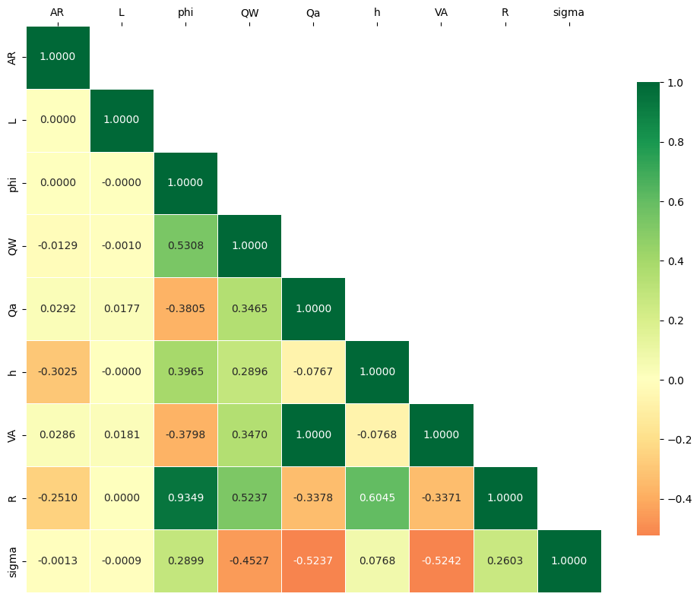
As a cornerstone of statistical analysis, the examination of variables and their inter-correlations is an indispensable tool for unravelling the intricate relationships within an experimental dataset. Variable analysis delves into the characteristics of individual parameters, while correlation diagrams provide a quantitative, visual representation of the strength and direction of the linear relationships between pairs of variables. These diagrams employ correlation coefficients, which range from -1 to +1, where values approaching +1 indicate a strong positive correlation, values approaching -1 signify a strong inverse correlation, and values near 0 suggest a negligible linear relationship. This analysis is crucial for identifying significant parameters and understanding potential multicollinearity before model development. The correlation diagrams for the dimensional and non-dimensional datasets are presented in Figs. 4.1(a) and 4.1(b), respectively
(a)
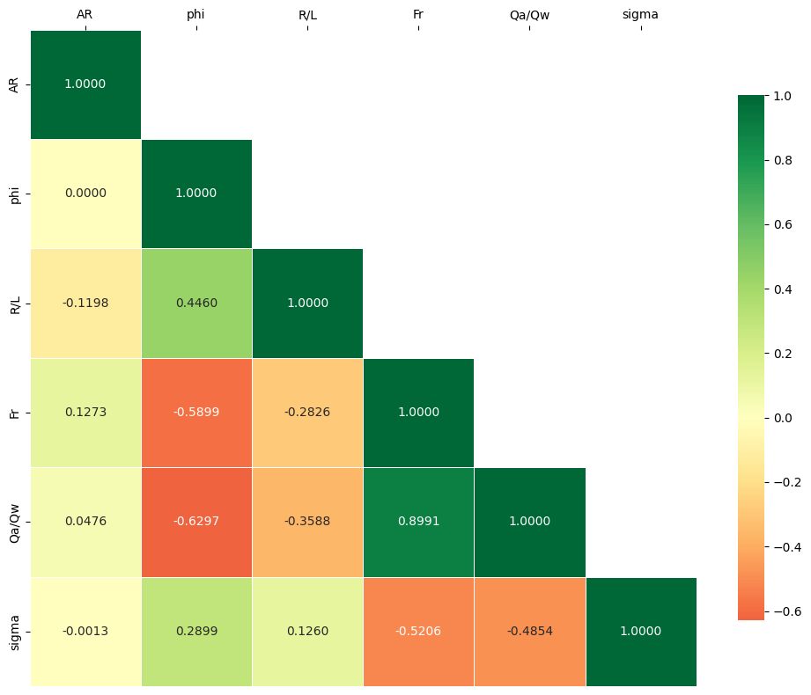
Figure 4.1 Correlation plots for the (a) dimensional and (b) non-dimensional datasets.
(b)
An analysis of the dimensional correlation matrix [Fig. 4.1 (a)] reveals several noteworthy relationships. The cavitation index (σ) exhibits its strongest correlations with flow-related parameters. Specifically, there are significant inverse relationships between σ and the air velocity ($V_{a}$​) with a coefficient of -0.5242, the air flow rate ($Q_{a}$​) at -0.5237, and the water flow rate ($Q_{w}$​) at -0.4527. These findings suggest that higher flow rates and air velocities correspond to a lower cavitation index, indicating an increased risk of cavitation. Conversely, a moderate positive correlation is observed between σ and the gate opening rate (φ) at 0.2899. Furthermore, a very strong positive correlation of 0.9349 is identified between the gate opening rate (φ) and the hydraulic radius (R), which is expected
as a larger gate opening directly influences the flow geometry. The non-dimensional analysis [Fig. 4.1 (b)] provides further insight into the fundamental hydraulic relationships. The most significant finding is the strong inverse correlation between the cavitation index (σ) and the Froude number ($F_{r}$), with a coefficient of -0.5206. This confirms the critical role of the flow regime, indicating that as inertial forces become more dominant relative to gravitational forces (higher $F_{r}$), the cavitation index decreases. A similarly strong inverse correlation is observed between σ and the air-demand ratio $\left(Q_{a}​/Q_{w}​\right)$ at -0.4854. This implies that a higher ratio of entrained air to water flow is associated with a lower cavitation index. The gate opening rate (φ) maintains a moderate positive correlation with σ at 0.2899, consistent with the dimensional analysis. In summary, the dimensional analysis highlights that the kinematic and dynamic properties of the flow, specifically the air and water velocities and flow rate are the most dominant factors influencing the cavitation index. The non-dimensional analysis confirms this from a theoretical standpoint, identifying the Froude number and the air-demand ratio as the most critical predictive parameters. These insights provide a robust foundation for variable selection and the subsequent development of predictive machine learning models.
 |  | Training |  |  |  | Testing
S. No. | Model | CC | RMSE | MAE |  | CC | RMSE | MAE
1 | GBM | 1.0000 | 0.0237 | 0.0191 |  | 0.9998 | 0.3632 | 0.2645
2 | XGB | 0.9999 | 0.2708 | 0.1927 |  | 0.9883 | 3.0582 | 0.9845
3 | CATB | 1.0000 | 0.0630 | 0.0499 |  | 0.9984 | 1.0440 | 0.6253
4 | XRT | 1.0000 | 0.0612 | 0.0368 |  | 0.9997 | 0.4645 | 0.3396
5 | RF | 0.9995 | 0.5512 | 0.2918 |  | 0.9922 | 2.3566 | 0.6922
6 | MLR | 0.7747 | 10.6866 | 7.8934 |  | 0.7902 | 11.5881 | 8.5894
7 | MNLR | 0.8811 | 7.9938 | 5.9824 |  | 0.8869 | 8.6708 | 6.5976
Table 4.1 Performance of different models on dimensional dataset

4.2 Comparison of Results for Dimensional Data
This section presents a systematic and comprehensive evaluation of the predictive performance of the seven proposed models, utilizing the dimensional dataset derived from the experimental investigation. The analysis framework is designed to rigorously compare the efficacy of advanced ensemble machine learning paradigms (GBM, XRT, CatBoost, RF, XGBoost) against conventional statistical regression techniques (MLR, MNLR). This comparative assessment is critical for validating the application of sophisticated computational intelligence models to complex hydraulic phenomena such as cavitation. The performance of each model was quantitatively assessed using the Coefficient of Correlation (CC), Root Mean Square Error (RMSE), and Mean Absolute Error (MAE), with the comprehensive results summarized in Table 4.1 To supplement this quantitative assessment, a thorough analysis of graphical evaluation, including scatter plots (Fig. 4.4), Taylor diagrams (Fig. 4.3), and a relative error plot (Fig. 4.2) was conducted to visually interpret model accuracy, bias, and variance.
The analysis of the testing results unequivocally highlights the superior predictive capabilities of the ensemble learning methodologies. Among this advanced cohort, the Gradient Boosting Machine (GBM) model emerged as the premier performer, delivering the most accurate predictions by achieving the lowest overall error. The GBM model yielded an exceptionally low RMSE of 0.363 and MAE of 0.264, signifying minimal average magnitude of error, while concurrently maintaining a near-perfect CC of 0.9981. Closely following was the Extra Trees (XRT) model, which achieved the highest correlation coefficient among all models (CC of 0.9997) with only marginally higher errors (RMSE of 0.464). The CatBoost model further affirmed the robustness of the gradient boosting approach, registering a strong CC of 0.9984. The success of these models can be attributed to their architectural strengths, the boosting algorithms (GBM, CatBoost) excel at bias reduction by sequentially correcting errors, while the randomization inherent in bagging methods (XRT) is highly effective at variance reduction, which likely explains XRT's exceptional correlation score. A detailed examination of the scatter plots [Fig. 4.4(b)] for the testing phase visually substantiates these quantitative findings. The predictions from the top-tier models (GBM, XRT, and CatBoost) exhibit a dense concentration along the line of perfect agreement (y=x), indicating a strong and consistent mapping of input features to the cavitation index. Most of their predictions fall well within the predefined error bands, demonstrating a low and homoscedastic error profile across the entire range of experimental values. In stark contrast, the scatter plot reveals the significant limitations of the baseline models. The predictions for MLR and MNLR are widely dispersed and show systematic deviation from the ideal line, particularly for cavitation index values below zero and above 20, with numerous points falling outside the error bands. This visual evidence confirms their lower predictive power and inability to capture the full complexity of the physical process Further corroboration of these performance rankings is provided by the Taylor diagram for the testing data [Fig. 4.3(b)]. This diagram offers a consolidated statistical summary of model fidelity by simultaneously plotting correlation, standard deviation, and cantered-root-mean square-difference. The diagram clearly illustrates that the points representing GBM, XRT, and CatBoost are clustered almost exactly on top of the ‘Experimental’ reference point. This positioning signifies a near-perfect correlation (CC ≈ 1.0), an almost identical standard deviation to the observed data, and a minimal cantered-root-mean-square-difference, confirming their high statistical fidelity. The relative error plot (Fig. 4.2) provides another perspective, showing that the ensemble models maintain a stable error profile fluctuating close to zero, whereas the MLR and MNLR models are characterized by frequent, high-magnitude error spikes, indicating their unreliability for specific predictive instances. A comparison between the training [Fig. 4.3 (a)] and testing [Fig. 4.3 (b)] phases on the Taylor diagrams indicates that all models performed better on the data they were trained on, which is expected. However, the performance degradation for the top-performing ensemble models like GBM and XRT was minimal, highlighting their excellent generalization capabilities and robustness against overfitting. In summary, the comprehensive analysis, supported by both quantitative metrics and extensive graphical evidence from multiple perspectives, unequivocally demonstrates the superiority of the ensemble learning techniques. The GBM model delivered the most robust overall performance, offering the optimal balance of high
(b)
correlation and minimal prediction error, thereby establishing it as the most suitable model for predicting the cavitation index from dimensional parameters.
Figure 4.2 Relative error plot for all models on the dimensional dataset

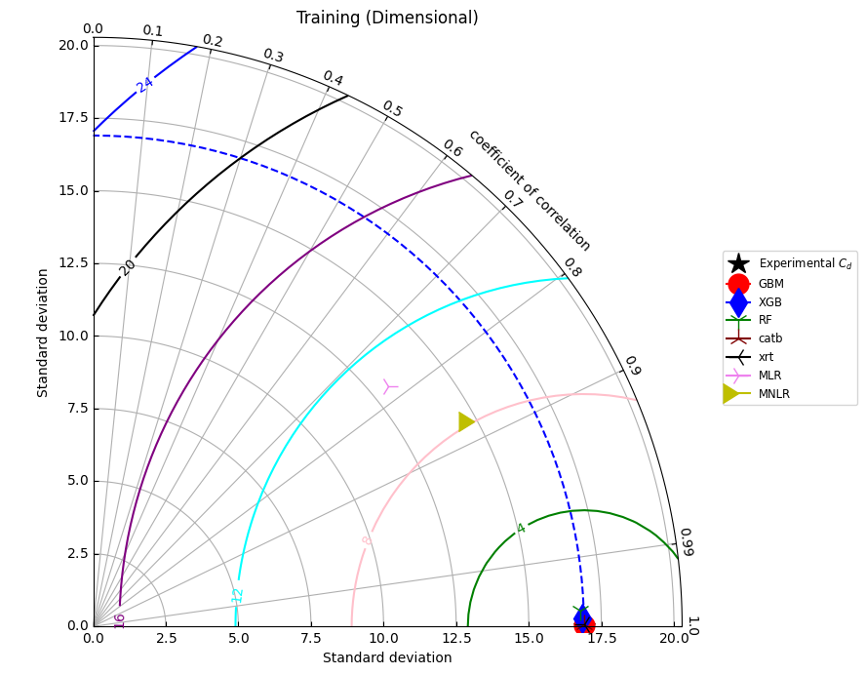

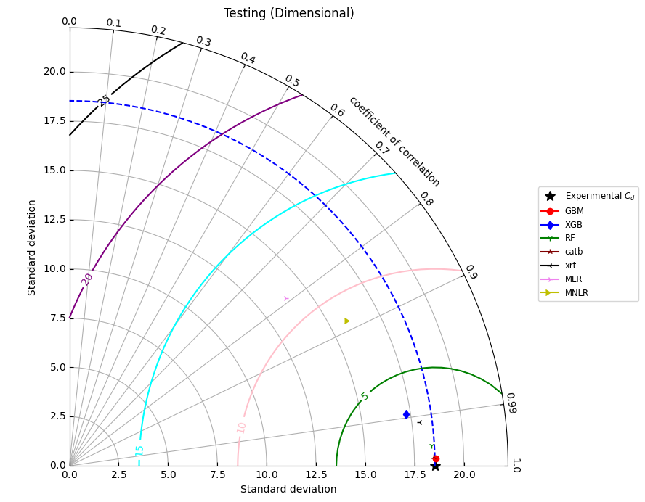
Figure 4.3 Taylor diagrams comparing model performance for (a) Training and (b) Testing phases
Figure 4.4 Scatter plots of predicted vs. actual cavitation index for (a) Training and (b) Testing phases for dimensional dataset
(b)
(a)
 |  | Training |  |  |  | Testing
S. No. | Model | CC | RMSE | MAE |  | CC | RMSE | MAE
1 | GBM | 1.0000 | 0.0284 | 0.0203 |  | 0.9999 | 0.2536 | 0.1883
2 | XGB | 0.9999 | 0.2341 | 0.1790 |  | 0.9929 | 2.2629 | 0.9950
3 | CATB | 1.0000 | 0.1077 | 0.0858 |  | 0.9940 | 2.2702 | 0.7305
4 | XRT | 1.0000 | 0.0010 | 0.0005 |  | 0.9936 | 2.1851 | 0.5207
5 | RF | 0.9997 | 0.4201 | 0.2438 |  | 0.9991 | 0.8091 | 0.5576
6 | MLR | 0.5269 | 14.3647 | 9.5120 |  | 0.5262 | 15.8059 | 10.5582
7 | MNLR | 0.7280 | 11.5876 | 7.6576 |  | 0.7329 | 12.6522 | 8.4276
Table 4.2 Performance of different models on non-dimensional dataset

4.3 Comparison of Results for Non-Dimensional Data
The investigation proceeded to a comprehensive analysis of the non-dimensional dataset to develop a more universally applicable predictive model based on fundamental hydraulic parameters. This approach, which normalizes input features to remove scale dependency, is crucial for testing a model's ability to capture the underlying physics of the cavitation phenomenon. The performance of all seven models was evaluated using the non-dimensional testing data, with quantitative results summarized in Table 4.2. This statistical assessment is further contextualized and corroborated by a detailed analysis of the graphical evidence presented in the scatter plots (Fig. 4.4), the Taylor diagrams (Fig. 4.6), and the relative error plot (Fig. 4.5).
The analysis of the non-dimensional data starkly revealed the profound complexity of the relationships between the fundamental hydraulic parameters. This was most evident in the performance of the conventional regression models, which failed to produce meaningful predictions. The Multiple Linear Regression (MLR) and Multiple Nonlinear Regression (MNLR) models were found to be entirely inadequate for this task, yielding extremely high errors (RMSE of 15.81 and 12.65, respectively) and poor correlation coefficients (CC of 0.526 and 0.733). This pronounced inadequacy suggests that the relationships between dimensionless parameters such as the Froude number, air-demand ratio, and the cavitation index are governed by a high degree of non-linearity and complex interactions that are intractable for conventional regression methods.
In stark contrast, the advanced ensemble models were able to successfully navigate this intricate parameter space. The Gradient Boosting Machine (GBM) emerged as the unequivocally superior model, delivering a near-perfect prediction with a Coefficient of Correlation (CC) of 0.9999 and an exceptionally low Root Mean Square Error (RMSE) of 0.254. This error magnitude is more than three times lower than its closest competitor, showcasing a level of accuracy that far surpasses all other methods evaluated. The Random Forest (RF) model secured a distant but clear second place, also achieving a high correlation (CC of 0.9991) but with a significantly larger RMSE of 0.809. The remaining ensemble models, including XRT, CatBoost, and XGBoost, formed a subsequent performance tier, exhibiting strong correlations (CC > 0.992) but with substantially higher error metrics (RMSE > 2.1), indicating lower precision compared to GBM and RF.
This performance hierarchy is visually substantiated by the scatter plots of the testing data [Fig. 4.4 (b)]. The predictions from the GBM model form an exceptionally tight and linear cluster along the line of perfect agreement, demonstrating a highly accurate and unbiased fit with minimal variance. The RF model also shows a strong fit, albeit with slightly more discernible scatter. Conversely, the complete failure of the baseline models is apparent, with their predictions widely and erratically dispersed across the plot. The relative error plot (Fig. 4.5) further dramatizes this disparity. While the ensemble models maintain a relatively stable error profile fluctuating close to zero, the MLR and MNLR models are characterized by frequent, high-amplitude error spikes, signifying their unreliability and failure to generalize across the testing instances.
Figure 4.5 Relative error plot for all models on the non-dimensional dataset
A comparison between the training [Fig. 4.6(a)] and testing [Fig. 4.6 (b)] phases on the Taylor diagrams provides insight into model generalization. While all ensemble models show a tight clustering near the reference point during training, the GBM model maintains its position with almost no degradation in the testing phase, highlighting its exceptional robustness against overfitting. The diagram for the testing data [Fig. 4.6 (b)] offers a final, consolidated summary of statistical fidelity. The GBM model's point is positioned almost indistinguishably upon the ‘Experimental’ reference point, confirming a near-perfect statistical match. The RF model is also in proximity, while the other ensemble and baseline models are located at progressively greater distances, visually confirming their lower statistical correspondence to the observed data.

Figure 4.6 Scatter plots of predicted vs. actual cavitation index for (a) Training and (b) Testing phases for non-dimensional dataset
(b)
(a)
(a)

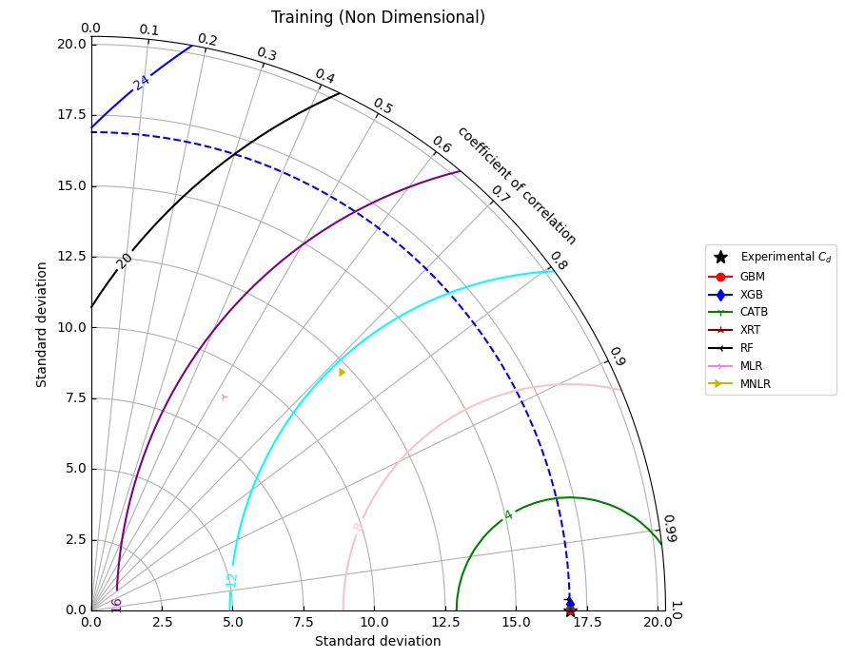

(a)
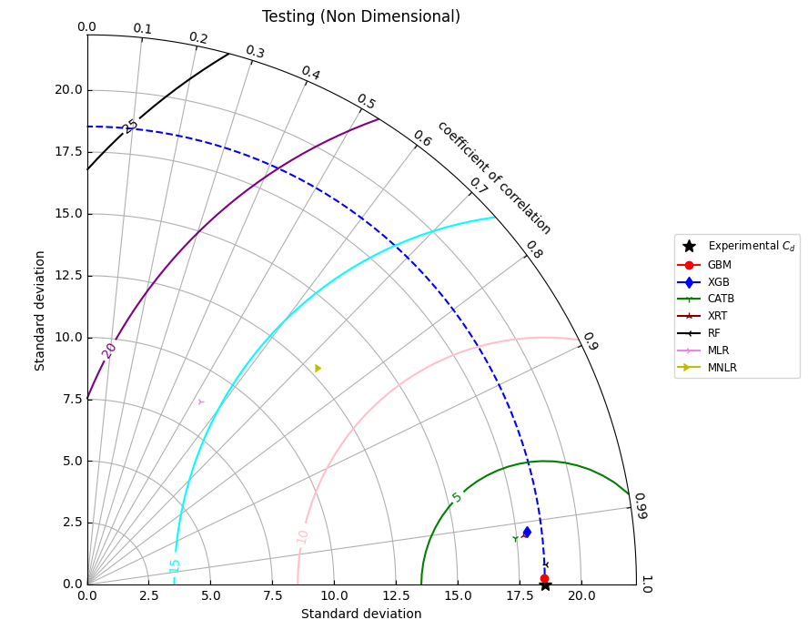
Figure 4.7 Taylor diagrams comparing model performance for the non-dimensional (a) Training and (b) Testing phases.
(b)
In conclusion, the non-dimensional analysis not only confirms the superiority of ensemble learning but also more definitively establishes the GBM as the most accurate and robust model. The process of non-depersonalization, while creating a more complex problem space that invalidates simpler regression techniques, enables the development of an exceptionally precise and generalizable predictive model when paired with an advanced computational framework like the Gradient Boosting Machine.

4.4 Sensitivity Analysis
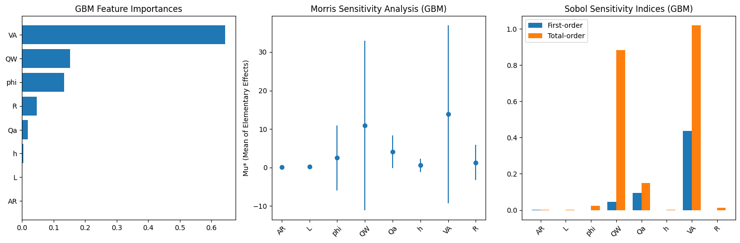
A comprehensive sensitivity analysis was conducted to quantify the influence of each input parameter on the predictive accuracy of the premier GBM model. Understanding which variables most significantly impact the model's output is critical for validating the model against physical principles, identifying key design parameters, and potentially simplifying the model by removing non-influential inputs. This study employs a multi-faceted approach, utilizing the straightforward One-Factor-at-a-Time (OFAT) method, the qualitative Morris method for screening, and the robust, variance-based Sobol method for a comprehensive quantitative assessment of parameter importance.
(a)
(b)
(c)
Figure 4.8 Sensitivity analysis results for the dimensional dataset, showing (a) GBM Feature Importances, (b) Morris Analysis, and (c) Sobol Indices.

4.4.1-Dimensional Dataset
The sensitivity analysis of the dimensional dataset revealed that the model's prediction of the cavitation index (σ) is driven by a complex interplay between several key parameters. The OFAT analysis, summarized in Table 4.3, provided the most direct evidence of parameter influence. The removal of the water flow rate ($Q_{w}$​) resulted in a catastrophic degradation of model performance, causing the testing RMSE to increase from 0.152 to 56.046, an increase of over 36,000%. This identifies $Q_{w}$​ as the single most critical parameter for the model's stability and accuracy. The Morris analysis [Fig. 4.7. (b)] further corroborates this, identifying air velocity ($V_{a}$) and water flow rate ($Q_{w}$​) as the parameters with the highest mean elementary effects (μ∗), indicating their strong overall influence. The large error bars associated with these two parameters also suggest significant non-linear effects and/or interactions with other variables.
Table 4.3 Sensitivity analysis using the OFAT on GBM model for dimensional dataset

Combination | Parameter Removed | Train CC | Train RMSE | Test CC | Test RMSE
$σ=f\left(AR,L,ϕ,Q_{w}​,Q_{a}​,h,V_{a}​,R\right)$ | — | 0.999999 | 0.000426 | 0.999782 | 0.151671
$σ=f\left(L,ϕ,Q_{w}​,Q_{a}​,h,V_{a}​,R\right)$ | $$AR$$ | 0.999999 | 0.000583 | 0.999807 | 0.133994
$σ=f\left(AR,ϕ,Q_{w}​,Q_{a}​,h,V_{a}​,R\right)$ | $$L$$ | 0.999999 | 0.000649 | 0.999785 | 0.149208
$σ=f\left(AR,L,Q_{w}​,Q_{a}​,h,V_{a}​,R\right)$ | $$ϕ$$ | 0.999999 | 0.000546 | 0.999808 | 0.132739
$σ=f\left(AR,L,ϕ,Q_{a}​,h,V_{a}​,R\right)$ | $$Q_{w}​$$ | 0.946054 | 29.989704 | 0.914857 | 56.046437
$σ=f\left(AR,L,ϕ,Q_{w}​,h,V_{a}​,R\right)$ | $$Q_{a}​$$ | 0.999999 | 0.000441 | 0.999837 | 0.113311
$σ=f\left(AR,L,ϕ,Q_{w},Q_{a}​,V_{a}​,R\right)$ | $$h$$ | 0.999999 | 0.000790 | 0.999337 | 0.468093
$σ=f\left(AR,L,ϕ,Q_{w},Q_{a}​,h,R\right)$ | $$V_{a}$$ | 0.999999 | 0.000735 | 0.999177 | 0.571065
$σ=f\left(AR,L,ϕ,Q_{w}​,Q_{a}​,h,V_{a}​\right)$ | $$R$$ | 0.999999 | 0.000666 | 0.999775 | 0.154887

The Sobol analysis [Fig. 4.7 (c)] offers the deepest insight into these interactions. It reveals that the effective water depth (h) has the largest first-order index ($S_{1}​$≈0.43), meaning it has the strongest direct, independent influence on the output variance. In contrast, the water flow rate ($Q_{w}$​) has a very low first-order index but the highest total-order index ($S_{T}​$≈0.9), indicating that its immense importance is almost entirely derived from its interactions with other parameters. In summary, for the dimensional dataset, the prediction of σ is primarily driven by the water flow rate, air velocity, and effective depth, with the influence of the flow rate being heavily interactive.
Table 4.4 Sensitivity analysis using the OFAT on GBM model for non-dimensional dataset

Combination | Parameter Removed | Train CC | Train RMSE | Test CC | Test RMSE
$σ=f\left(AR,ϕ,R/L,F_{r},Q_{a}​/Q_{w}​\right)$ | — | 0.999998 | 0.000953 | 0.999826 | 0.119661
$σ=f\left(ϕ,R/L,F_{r},Q_{a}​/Q_{w}​\right)$ | $$AR$$ | 0.999992 | 0.004538 | 0.999571 | 0.295044
$σ=f\left(AR,R/L,F_{r},Q_{a}​/Q_{w}​\right)$ | $$ϕ$$ | 0.999944 | 0.032125 | 0.994813 | 3.752492
$σ=f\left(AR,ϕ,F_{r},Q_{a}​/Q_{w}​\right)$ | $$R/L$$ | 0.999997 | 0.001939 | 0.99988 | 0.082639
$σ=f\left(AR,ϕ,R/L,Q_{a}​/Q_{w}​\right)$ | $$F_{r}$$ | 0.945853 | 30.097985 | 0.867971 | 85.062258
$σ=f(AR,ϕ,R/L,F_{r})$ | $$Q_{a}​/Q_{w}​$$ | 0.999989 | 0.006267 | 0.999734 | 0.190192

4.6.2 Non-Dimensional Dataset
The sensitivity analysis for the non-dimensional dataset yielded a remarkably clear and consistent result across all three methods. The Froude number ($F_{r}$) was unequivocally identified as the single most dominant parameter influencing the prediction of the cavitation index. The OFAT results (Table 4.4) show that removing $F_{r}$ from the model causes the testing RMSE to explode from 0.120 to 85.062, rendering the model useless. This finding is mirrored in the GBM feature importance plot [Fig. 4.8 (a)], where Fr has an importance value that dwarfs all other parameters combined.
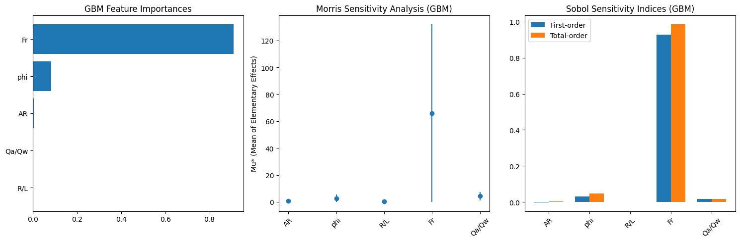
Figure 4.8 Sensitivity analysis results for the non-dimensional dataset, showing (a) GBM Feature Importances, (b) Morris Analysis, and (c) Sobol Indices.
(c)
(b)
(a)

The Morris and Sobol analyses provide a quantitative explanation for this dominance. The Morris plot [Fig. 4.8 (b)] shows $F_{r}$ having a μ∗ value an order of magnitude larger than any other parameter, confirming its overwhelming influence. Most decisively, the Sobol analysis [Fig. 4.8 (c)] shows that the first-order ($S_{1}$​) and total-order $\left(S_{T}​\right)$ indices for $F_{r}$ are both approximately 1.0. This indicates that the Froude number alone accounts for nearly 100% of the variance in the predicted cavitation index, and its influence is almost entirely direct and independent, with negligible interaction effects from other parameters like gate opening (ϕ) or aspect ratio (AR). This result is physically consistent, as the Froude number is a fundamental dimensionless parameter that describes the balance between inertial and gravitational forces, which is central to the formation of flow conditions that lead to cavitation. The analysis confirms that the GBM model successfully learned this fundamental hydraulic relationship from the data.

4.5 SHAP Analysis
To enhance the interpretability of the premier GBM model and move beyond its "black-box" nature, a SHAP (SHapley Additive exPlanations) analysis was conducted. SHAP is a state-of-the-art methodology rooted in cooperative game theory that explains the output of any machine learning model by computing the contribution of each feature to a specific prediction. SHAP values quantify both the magnitude and the direction of a feature's effect, providing a granular, instance-level understanding of the model's behavior. This analysis was performed on the GBM model for both the dimensional and non-dimensional datasets to elucidate the key drivers of the predicted cavitation index.

4.5.1-Dimensional Dataset
The SHAP analysis for the dimensional dataset provides a clear hierarchy of feature importance, which is consistent with the findings from the sensitivity analysis. The global feature importance, illustrated by the mean absolute SHAP value bar chart in Fig. 4.9 (b), identifies air velocity ($V_{a}$​) as the most influential parameter, followed closely by water flow rate ($Q_{w}$​) and air flow rate ($Q_{a}$​).
The beeswarm plot [Fig. 4.9 (a)] further clarifies the nature of these influences. It reveals a strong inverse relationship between these top features and the predicted cavitation index (σ). High values of $V_{a}$​, $Q_{w}$​, and $Q_{a}$​ (represented by red and purple dots) consistently produce large negative SHAP values, indicating that they strongly drive the model's prediction lower (i.e., towards a higher risk of cavitation). Conversely, low values of these features (blue dots) yield positive SHAP values, pushing the prediction higher. The gate opening rate (ϕ) also shows a significant impact however, it exhibits a positive relationship, where higher values of ϕ contribute to a higher predicted cavitation index.
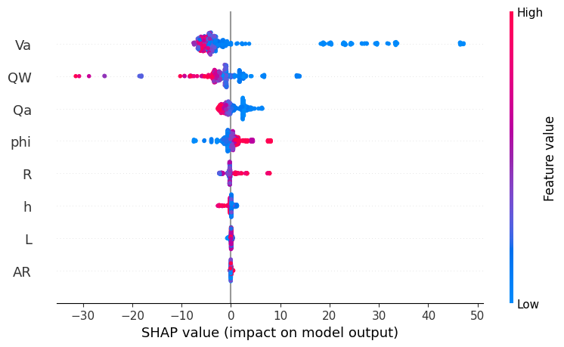
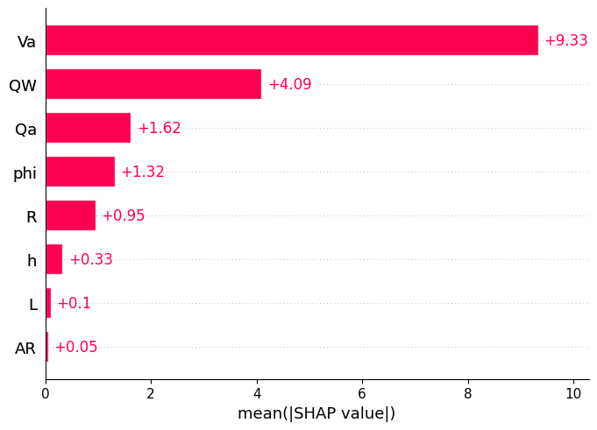
Figure 4.9 SHAP summary plots for the dimensional dataset on the testing data, showing (a) the beeswarm plot of SHAP values for each feature and (b) the bar chart of mean absolute SHAP values.
(b)
(a)

4.5.2 Non-Dimensional Dataset
For the non-dimensional dataset, the SHAP analysis reveals an even more distinct and dominant relationship, unequivocally confirming the results of the sensitivity analysis. The Froude number ($F_{r}$) is identified as the paramount feature, with a mean absolute SHAP value that is substantially larger than all other parameters combined, as shown in the bar chart in Fig. 4.10(b).
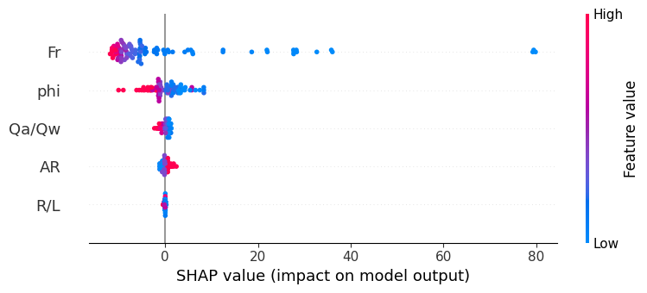
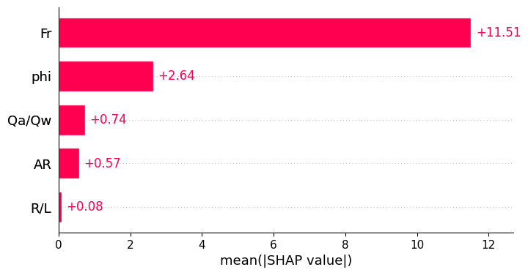
(b)
(a)
Figure 4.10 SHAP summary plots for the non-dimensional dataset on the testing data, showing (a) the beeswarm plot of SHAP values for each feature and (b) the bar chart of mean absolute SHAP values.
The beeswarm plot [Fig. 4.10 (a)] illustrates the powerful, direct influence of the Froude number on the model's output. There is a clear and strong inverse relationship: high values of $F_{r}$ (red dots) correspond to large negative SHAP values, significantly lowering the predicted cavitation index, while low values of $F_{r}$ (blue dots) correspond to positive SHAP values. The gate opening rate (ϕ) is the second most influential parameter, exhibiting a clear positive relationship with the predicted σ. Other parameters, such as the air-demand ratio ($Q_{a}​/Q_{w}$​) and aspect ratio (AR), have a comparatively minor impact. These findings validate that the GBM model successfully learned the fundamental physical relationship where the Froude number, as a key indicator of the flow regime, is the principal driver of cavitation potential in a non-dimensional context.

CHAPTER 5

CONCLUSION AND FUTURE WORK
This investigation analyses data from 504 comprehensive laboratory experiments conducted on radial-gated bottom outlets to predict the cavitation index (σ). Essential dimensional variables, such as air velocity ($V_{a}$) flow rate ($Q_{w}$), and gate opening (φ), and nondimensional variables, including the Froude number ($F_{r}$) and the air-demand ratio ($\frac{Q_{a}}{Q_{w}}$), were examined. Advanced machine learning (ML) models—specifically Gradient Boosting Machine (GBM), XGBoost, CatBoost, Extra Trees (XRT), and Random Forest (RF)—were systematically compared with conventional empirical models, Multiple Linear Regression (MLR) and Multiple Nonlinear Regression (MNLR).
The use of both dimensional and non-dimensional parameters in the study aimed to provide a comprehensive understanding of the system. Dimensional parameters are essential for direct, real-world applications and analysis, while non-dimensional parameters enable generalization and help capture the underlying physics, allowing the results to be applicable across different scales and conditions.
The Gradient Boosting Machine (GBM) model outperforms other models across all testing datasets. For the dimensional dataset, the GBM model achieves excellent predictive performance, with a coefficient of correlation (CC) of 0.9998, the lowest root means square error (RMSE) of 0.3632, and a minimal mean absolute error (MAE) of 0.2645. For the non-dimensional dataset, the GBM model demonstrates unequivocally superior performance, with a near-perfect CC of 0.9999, an RMSE of 0.2536, and an MAE of 0.1883. The Random Forest (RF) model ranked as the clear second-best in this category, achieving a CC of 0.9991 but with a significantly higher RMSE of 0.8091.
In contrast, the conventional regression models (MLR and MNLR) were found to be entirely inadequate for the non-dimensional data. These models yielded considerably poorer performance, with low correlation coefficients (0.526 for MLR) and high error metrics (RMSE of 15.81 for MLR), highlighting their inability to capture the complex, highly non-linear relationships inherent in the fundamental hydraulic parameters.
These results are further supported by a comprehensive visual analysis. Scatterplots depict the close alignment of the GBM model's estimated outcomes with the perfect agreement line, forming an "exceptionally tight and linear cluster". Conversely, the predictions from the baseline MLR and MNLR models were "widely and erratically dispersed". The Taylor diagram visually confirms the proximity of the GBM model to the actual (experimental) reference point, signifying near-perfect statistical fidelity. Additionally, relative error plots consistently display minimal error values for the GBM model, in stark contrast to the "frequent, high-magnitude error spikes" characteristic of the regression models.
The GBM model's superior performance is attributed to its architectural strength. As a boosting algorithm, it excels at bias reduction by sequentially and additively correcting the errors of preceding weak learners. This process allows the model to capture the complex, non-linear patterns, and interactions that conventional regression methods fail to identify. The model also demonstrated exceptional robustness against overfitting, maintaining its high performance from the training phase into the testing phase with minimal degradation.
Further supporting these results, the correlation and sensitivity analyses identify key relationships between variables. For the dimensional dataset, correlation analysis revealed strong inverse relationships between the cavitation index (σ) and air velocity ($V_{a},-0.5242$) and water flow rate ($Q_{w}$ ,-0.4527). The comprehensive sensitivity analysis (OFAT, Morris, and Sobol) confirmed that $Q_{w}$, $V_{a}$ and effective water depth (h) are the most influential parameters. In the non-dimensional dataset, the analysis is even more decisive: the Froude number ($F_{r}$) is identified as the most critical predictive parameter, with a strong inverse correlation of -0.5206. The sensitivity and SHAP analyses confirm that $F_{r}$ is the "single most dominant parameter," responsible for nearly 100% of the model's output variance. This validates that the GBM model successfully learned the fundamental hydraulic relationship governing cavitation potential.
This laboratory-based study relies on data from a specific set of experimental configurations and a single apparatus. This focus on controlled conditions, while necessary for the analysis, may limit the direct generalizability of the findings to different conduit geometries or large-scale, real-world applications where scale effects may be present. To enhance generalizability, future research should explore a broader range of experimental conditions and geometries. Investigating the model's performance on large-scale field studies under real-world conditions would be essential to validate these laboratory-based results.

REFERENCES

Falvey, H. T. (1990). Cavitation in chutes and spillways (p. 145). Denver, CO, USA: US Department of the Interior, Bureau of Reclamation.

Lee, W., & Hoopes, J. A. (1996). Prediction of cavitation damage for spillways. Journal of Hydraulic Engineering, 122(9), 481-488.

Chanson, H. (1994). Aeration and deaeration at bottom aeration devices on spillways. Canadian Journal of Civil Engineering, 21(3), 404-409.

Dong, Z. Y., & Su, P. L. (2006). Cavitation control by aeration and its compressible characteristics. Journal of Hydrodynamics, 18(4), 499-504.

Baylar, A., & Batan, M. (2010). Usage of artificial intelligence methods in free flowing gated closed conduits for estimation of oxygen transfer efficiency. Advances in Engineering Software, 41(5), 729-736.

Fadaei Kermani, E., Barani, G. A., & Ghaeini-Hessaroeyeh, M. (2015). Prediction of cavitation damage on spillway using K-nearest neighbor modeling. Water Science and Technology, 71(3), 347-352

Unsal, M., Baylar, A., Kayadelen, C., & Ozkan, F. (2014). The modeling of oxygen transfer efficiency in gated conduits by using genetic expression programming. Journal of Engineering Research, 2(2), 2.

Zounemat-Kermani, M., Rajaee, T., Ramezani-Charmahineh, A., & Adamowski, J. F. (2017). Estimating the aeration coefficient and air demand in bottom outlet conduits of dams using GEP and decision tree methods. Flow Measurement and Instrumentation, 54, 9-19.

Fadaei-Kermani, E., Barani, G. A., & Ghaeini-Hessaroeyeh, M. (2016). Numerical detection of cavitation damage on dam spillway. Civil Engineering Journal, 2(9), 484-490.

Fadaei Kermani, E., Barani, G. A., & Ghaeini-Hessaroeyeh, M. (2018). Cavitation damage prediction on dam spillways using Fuzzy-KNN modeling. Journal of Applied Fluid Mechanics, 11(2), 323-329.

Wahl, T. L., & Falvey, H. T. (2022). SpillwayPro: Integrated Water Surface Profile, Cavitation, and Aerated Flow Analysis for Smooth and Stepped Chutes. Water 2022, 14, 1256

Matos, J., Novakoski, C. K., Ferla, R., Marques, M. G., Dai Prá, M., Canellas, A. V. B., & Teixeira, E. D. (2022). Extreme pressures and risk of cavitation in steeply sloping stepped spillways of large dams. Water, 14(3), 306.

Nikrou, P., & Pirboudaghi, S. (2024). Numerical Analysis of Cavitation Dynamics on Free Ogee Spillways Using the Volume of Fluid (VOF) Method. arXiv preprint arXiv:2412.00695.

Abbas, M. Q., Hilo, A. N., & Al-Gasham, T. S. (2024). Numerical Modeling of Cavitation-Induced Abrasion in Ogee Spillways. Mathematical Modelling of Engineering Problems, 11(11).

Bagherzadeh, S., Ghaeini-Hessaroeyeh, M., & Fadaei-Kermani, E. (2025). Prediction of cavitation damage using SVM model based on air–water two-phase flow over dam spillway. Applied Water Science, 15(4), 70.

